Task 1-
Create a S3 bucket, with no public access and upload files to the bucket & view the logs using cloudwatch for the uploaded files.

- Created s3 bucket with no public access

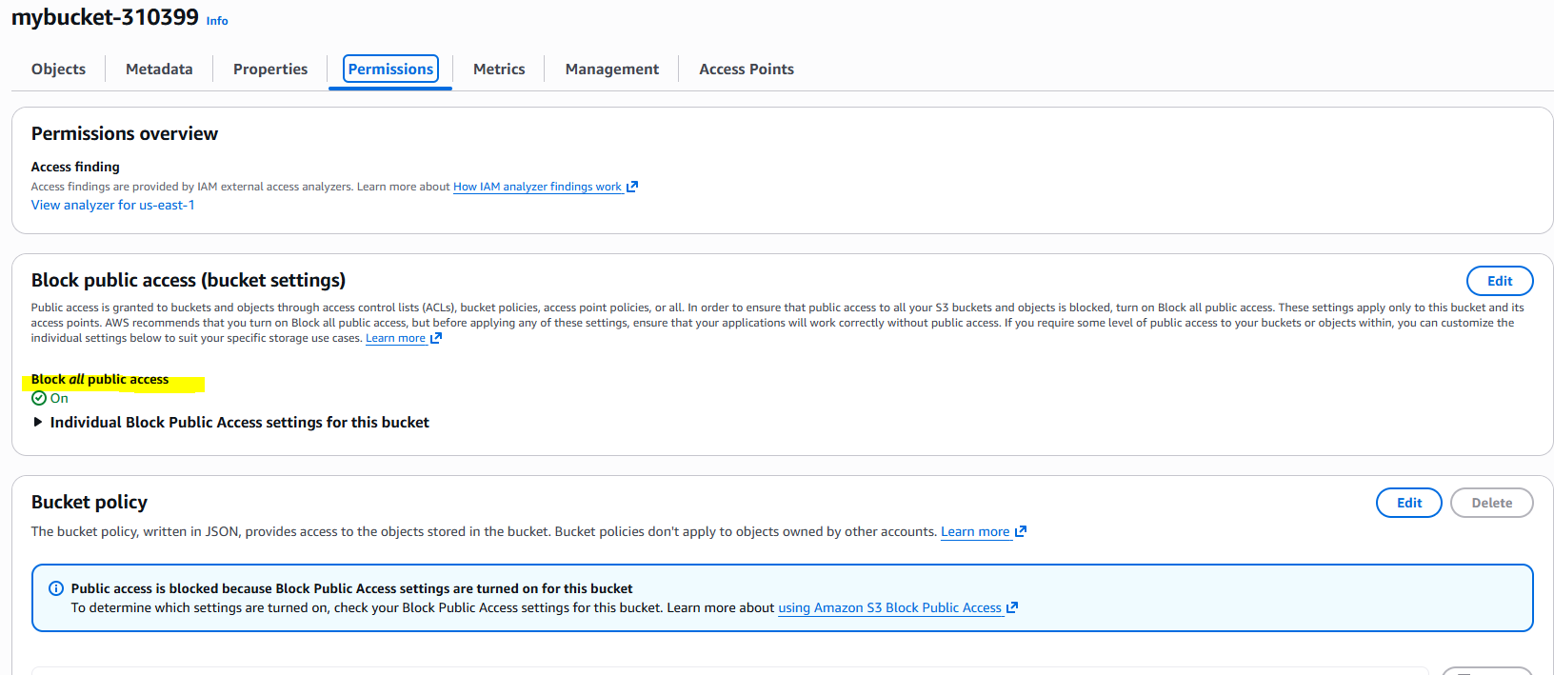

- Upload files to the S3 bucket

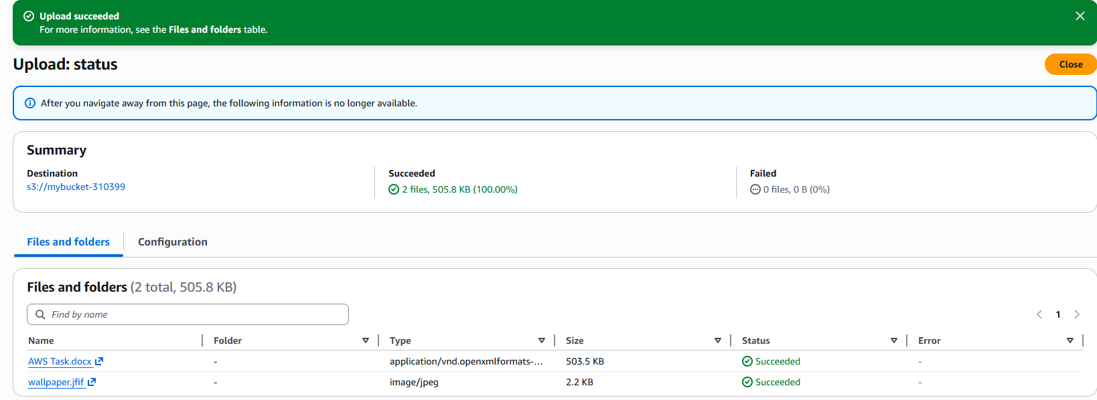

- Watch logs using cloudwatch

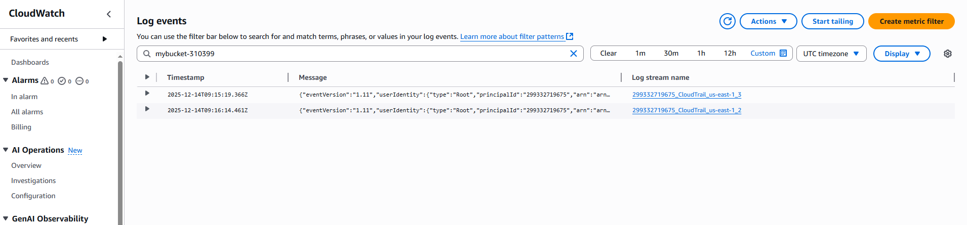

Task 2
Launch two ec2-instances and connect it to a application load balancer, where the output traffic from the server must be an load balancer IP address

- Launch 2 ec2- instance

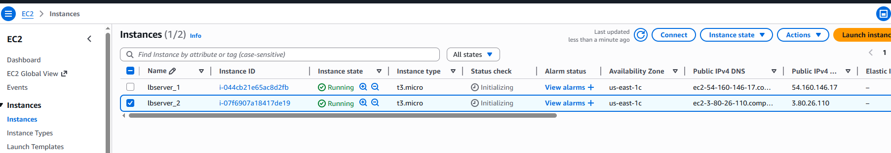

- Create application Load balancer

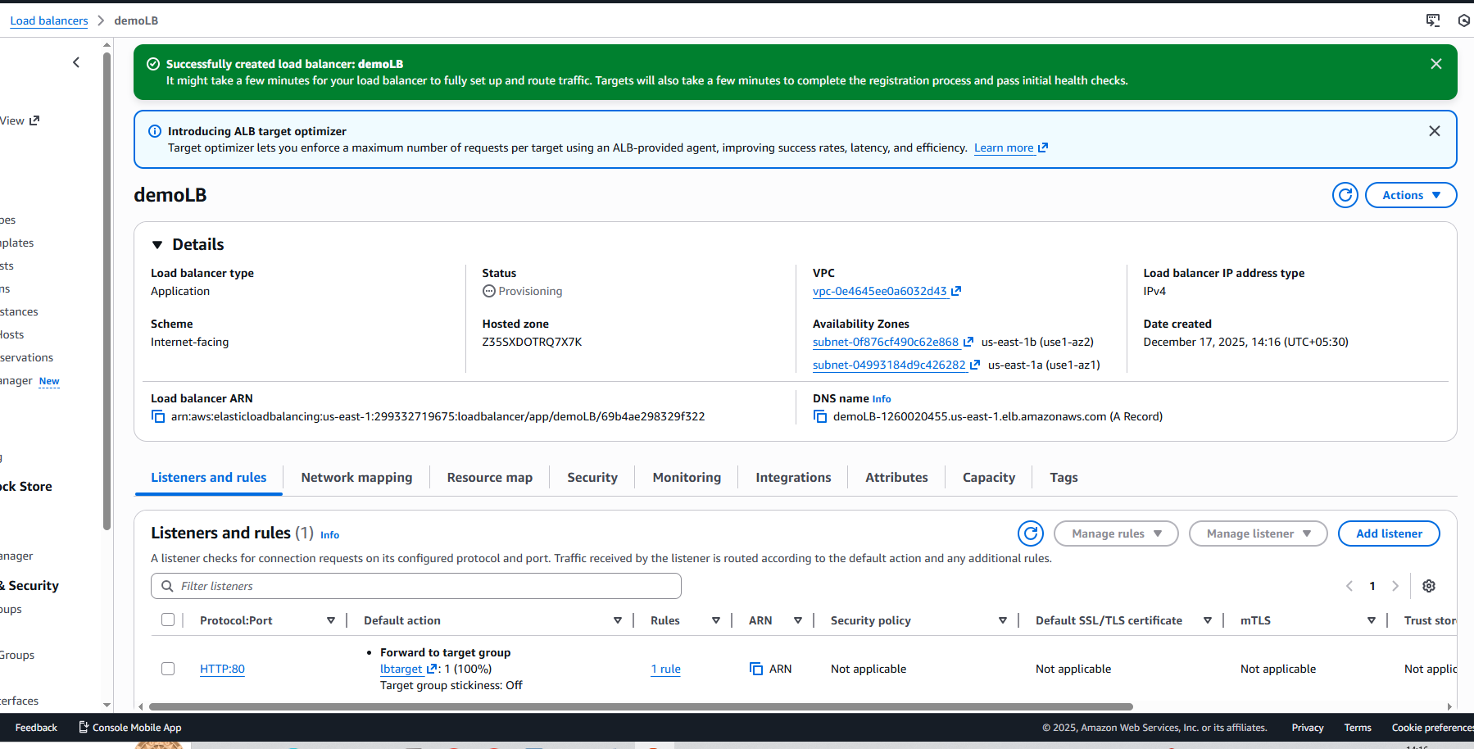

- Now check the traffic from load balancer DNS name

